S_TIDE Toolbox Tutorial 1.1
Haidong Pan (潘海东)
Key Laboratory of Physical Oceanography, Ocean University of China, Qingdao 266003, China
email: panhaidong_phd@qq.com

2020/05/10

  - Download and install S_TIDE toolbox
Users can download the latest S_TIDE toolbox from my researchgate: https://www.researchgate.net/project/A-non-stationary-tidal-analysis-toolbox-S-TIDE
Reference：
https://www.researchgate.net/publication/327274063_Exploration_of_Tidal-Fluvial_Interaction_in_the_Columbia_River_Estuary_Using_S_TIDE

  - S_TIDE Examples
    - Extracting linear trend using S_TIDE
First, you need to load data provided by S_TIDE, namely, K1_amp_hilo.mat. It should be noted that the codes below can be directly copied into MATLAB, then, you can run these codes.
load K1_amp_hilo.mat
plot(K1_amp,'r','linewidth',1.2); hold on
set(gca,'Fontsize',15,'linewidth',1.2)
xlabel('Months');ylabel('K1 amplitude')
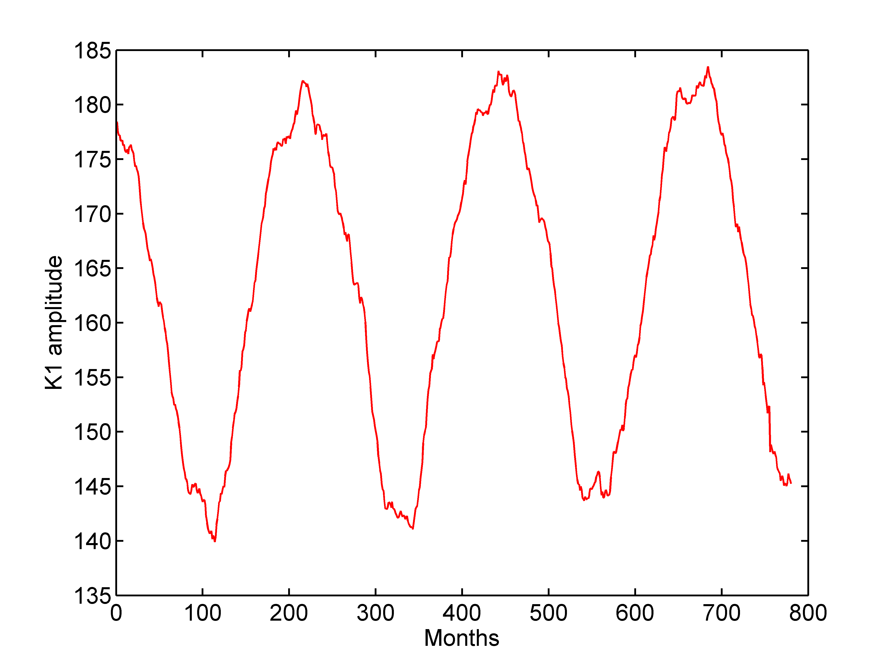
Figure 1. The monthly K1 tidal amplitudes at Hilo. You can clearly see the linear trend as well as the 18.61 year nodal cycle (about 223.32 months).

The codes below demonstrate how to extract the linear trend using S_TIDE toolbox. You need to set IDP1 and IDP2 as 2 and 0, respectively. 720 mean that the sampling interval is 720 hours (namely one month). 1/(18.61*8760) represent the 18.61 nodal cycle in the data (Because the corresponding independent point (IP) is set as 0, the obtained linear trend is not influenced by this input parameter )

[St,Ht,Gt,coef,xout,ju,Stint,Htint,Gtint]=s_tide(K1_amp,2,0,[1/(18.61*8760)],1,720,'spline','ols');
plot(St,'k','linewidth',1.2)
plot(St+Stint,'k--','linewidth',1.2)
plot(St-Stint,'k--','linewidth',1.2)

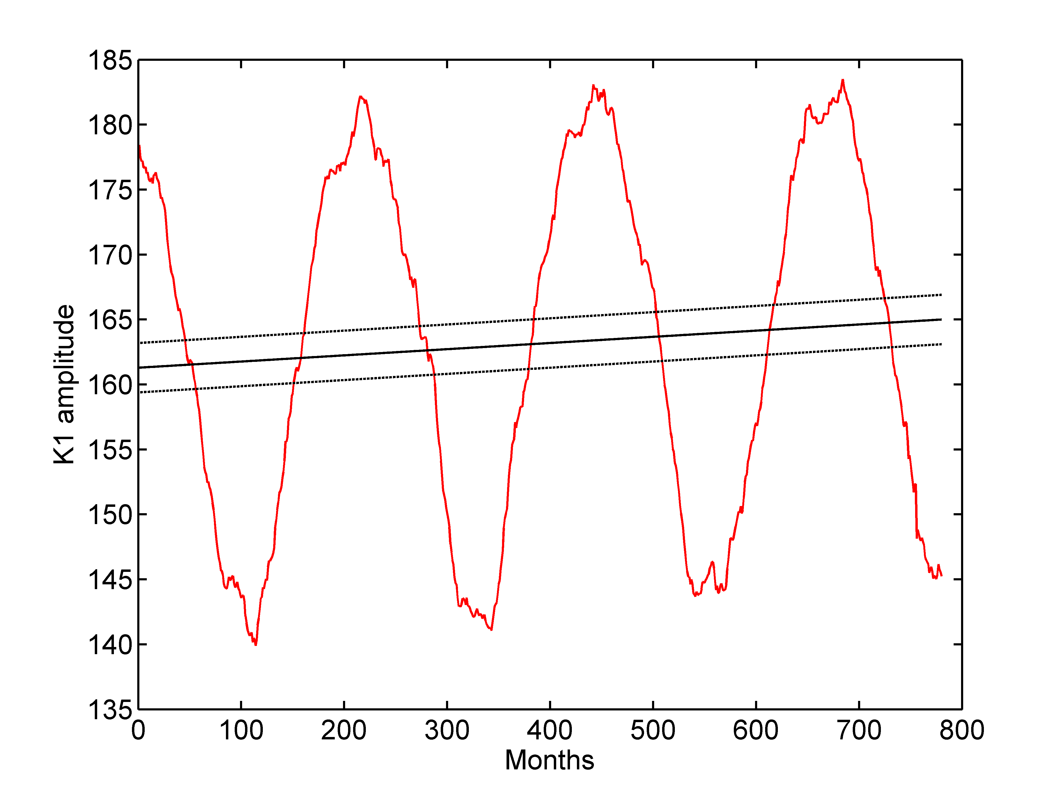
Figure 2. The linear trend obtained by S_TIDE（black solid line）as well as the 95% confidence interval（black dash lines）

    - Extracting nonlinear trend using S_TIDE
The codes below demonstrate how to extract the nonlinear trend using S_TIDE. You need to set IDP1 as 3. The results are shown in the Figure 3.

[St,Ht,Gt,coef,xout,ju,Stint,Htint,Gtint]=s_tide(K1_amp,3,0,[1/(18.61*8760)],1,720,'spline','ols');
plot(St,'k','linewidth',1.2)
plot(St+Stint,'k--','linewidth',1.2)
plot(St-Stint,'k--','linewidth',1.2)
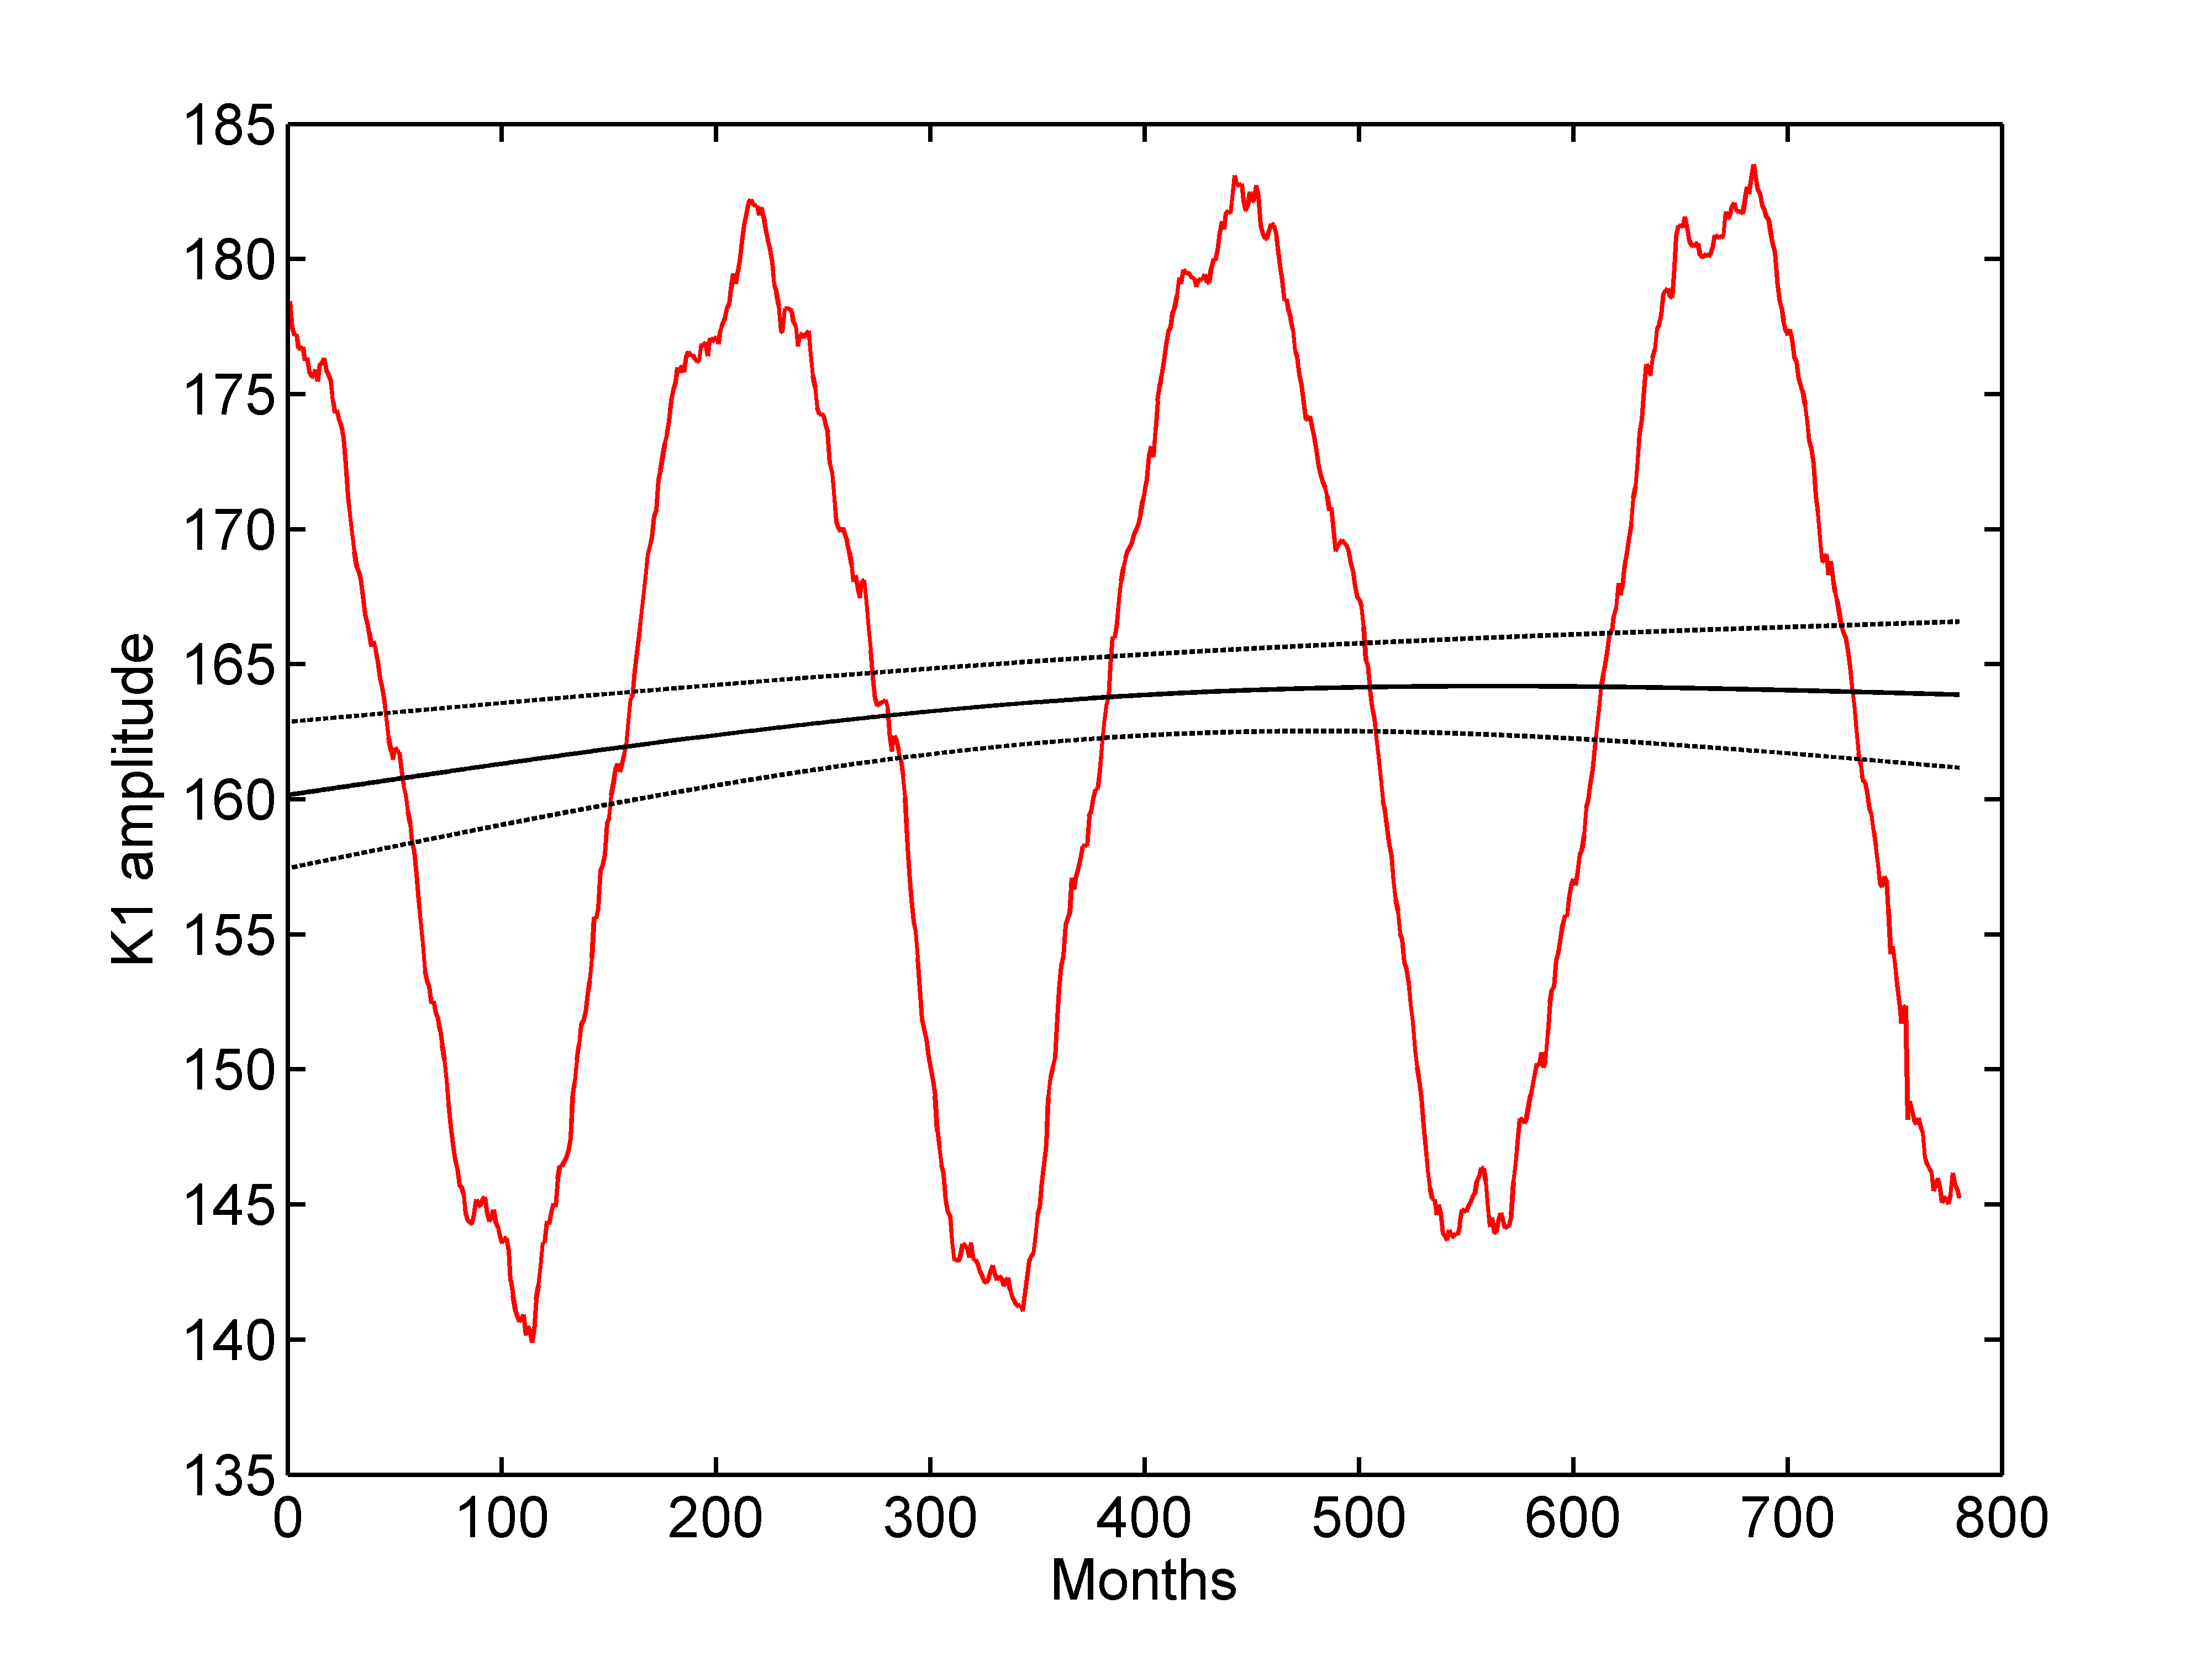
Figure 3. The nonlinear trend obtained by S_TIDE（black solid line）as well as the 95% confidence interval（black dash lines）
    - Compared to detrend function provided by MATLAB
The MATLAB function detrend can be used to extract the linear trend of the data, however, this function requires that the input data cannot have missing values. Compared to detrend, S_TIDE allows the missing values in the input. Also, we can use S_TIDE to extract nonlinear trends.

    - Extracting stationary cycles using S_TIDE
The codes below demonstrate how to extract stationary 18.61 nodal cycle using S_TDE. You should set IDP2 as 1 which means that the amplitude and phase of 18.61 nodal cycle are constant). It should be noted that the output parameter xout contains both 18.61 cycle and the linear trend. The results are displayed in Figure 4, 5 and 6.
load K1_amp_hilo.mat
figure();plot(K1_amp,'r','linewidth',1.2); hold on
set(gca,'Fontsize',15,'linewidth',1.2)
xlabel('Months');ylabel('K1 amplitude')
[St,Ht,Gt,coef,xout,ju,Stint,Htint,Gtint]=s_tide(K1_amp,2,1,[1/(18.61*8760)],1,720,'spline','ols');
plot(xout,'k','linewidth',1.2)

figure();plot(xout-St,'b','linewidth',1.2);
set(gca,'Fontsize',15,'linewidth',1.2);grid on; xlabel('Months');
figure();plot(Ht,'b','linewidth',1.2);
set(gca,'Fontsize',15,'linewidth',1.2);grid on;
xlabel('Months');ylabel('Amplitude')

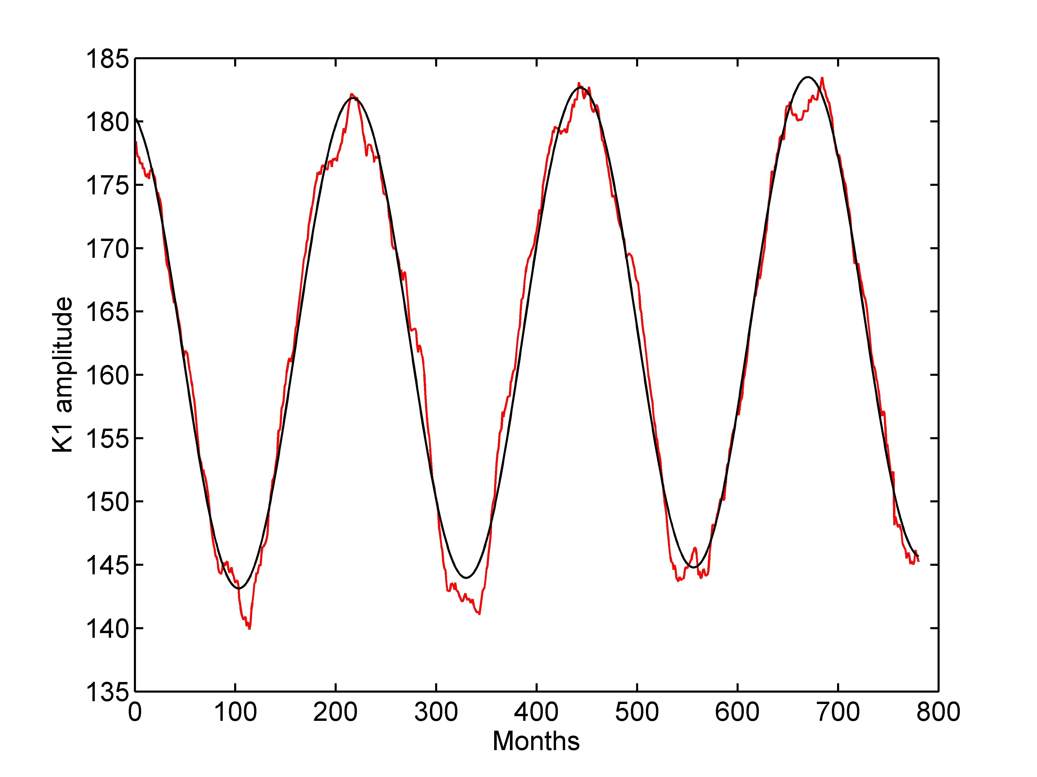
Figure 4. 18.61 nodal cycle (contains the linear trend) extracted by S_TIDE (black line) as well as the original data (red line)

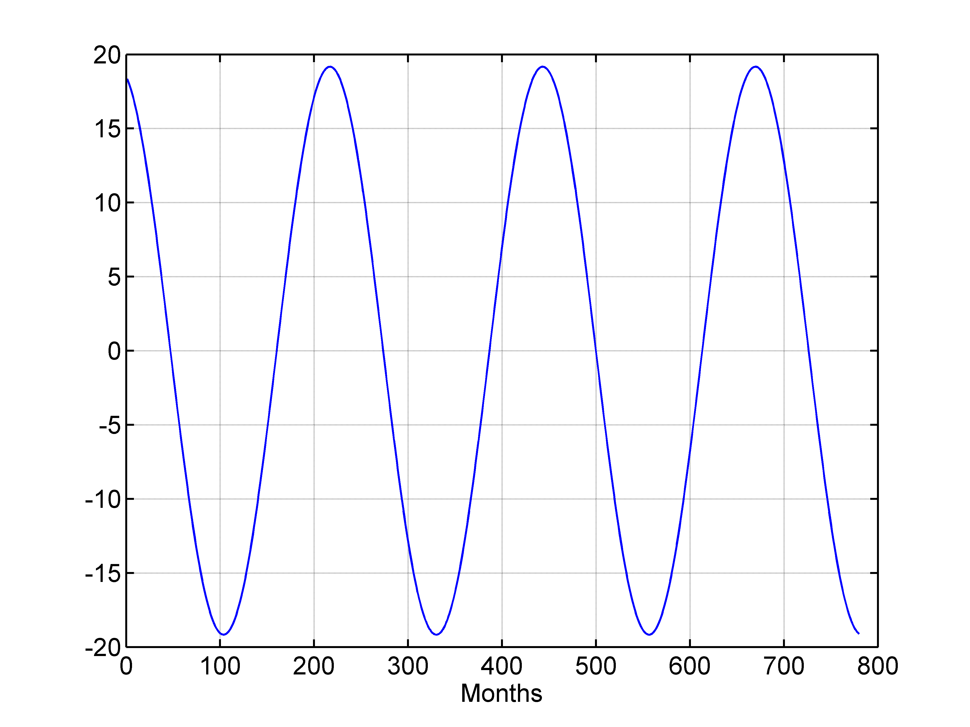
Figure 5. Detrended 18.61 nodal cycle

The output parameters Ht and Gt represent the amplitudes and phases of 18.61 nodal cycle, respectively. Because the corresponding IP number is set as one, the obtained amplitudes and phases are constant (as shown in Figure 6). In case of a linear response of the ocean to tidal forcing, the amplitude of the M2 nodal cycle is 3.73% of the tidal amplitude and the amplitude of the K1 nodal cycle is 11.5% of the tidal amplitude which are implicitly indicated by the tidal potential. At Hilo，the amplitude of the K1 nodal cycle is 11.72% of the tidal amplitude (using the code below)，which is nearly equal to the theoretical value.
mean(Ht)/mean(St)*100

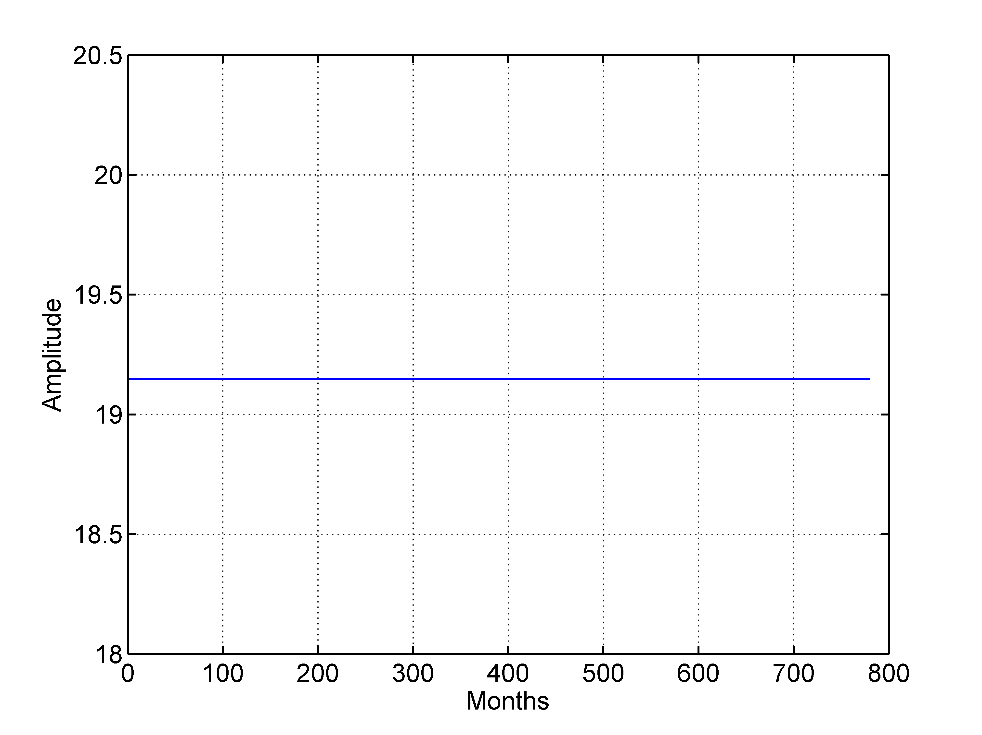
Figure 6. The extracted amplitudes of 18.61 nodal cycle

    - Extracting multi-cycles using S_TIDE
The codes below illustrate how to extract 18.61 year cycle and 8.85 year cycle simultaneously using S_TIDE. The results are shown in Figure 7 and 8. It should be noted that the input parameter ntides is set as 2 (marked in red in the codes below).
load N2_amp_astoria.mat
[St,Ht,Gt,coef,xout,ju,Stint,Htint,Gtint]=s_tide(N2_amp,2,1,[1/(18.61*8760);1/(8.85*8760)],2,720,'spline','ols');
plot(N2_amp,'r','linewidth',1.2);
set(gca,'Fontsize',15,'linewidth',1.2)
hold on;plot(xout,'k','linewidth',1.2);
xlabel('Months');ylabel('Amplitude')

figure();plot(Ht(1,:),'r','linewidth',1.2); hold on
plot(Ht(1,:)+Htint(1,:),'r--','linewidth',1.2);
plot(Ht(1,:)-Htint(1,:),'r--','linewidth',1.2);

plot(Ht(2,:),'k','linewidth',1.2); hold on
plot(Ht(2,:)+Htint(2,:),'k--','linewidth',1.2);
plot(Ht(2,:)-Htint(2,:),'k--','linewidth',1.2);
set(gca,'Fontsize',15,'linewidth',1.2);grid on;
xlabel('Months');ylim([0 10]);ylabel('Amplitude')

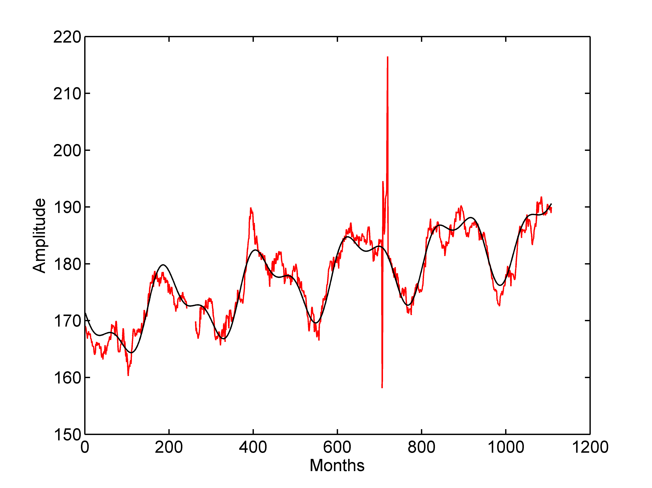
Figure 7. The red line means the monthly N2 tidal amplitudes at Astoria. You can clearly observe the linear trend, the 18.61 year cycle as well as the 8.85 year cycle. The black line represents the fitting results obtained by S_TIDE.

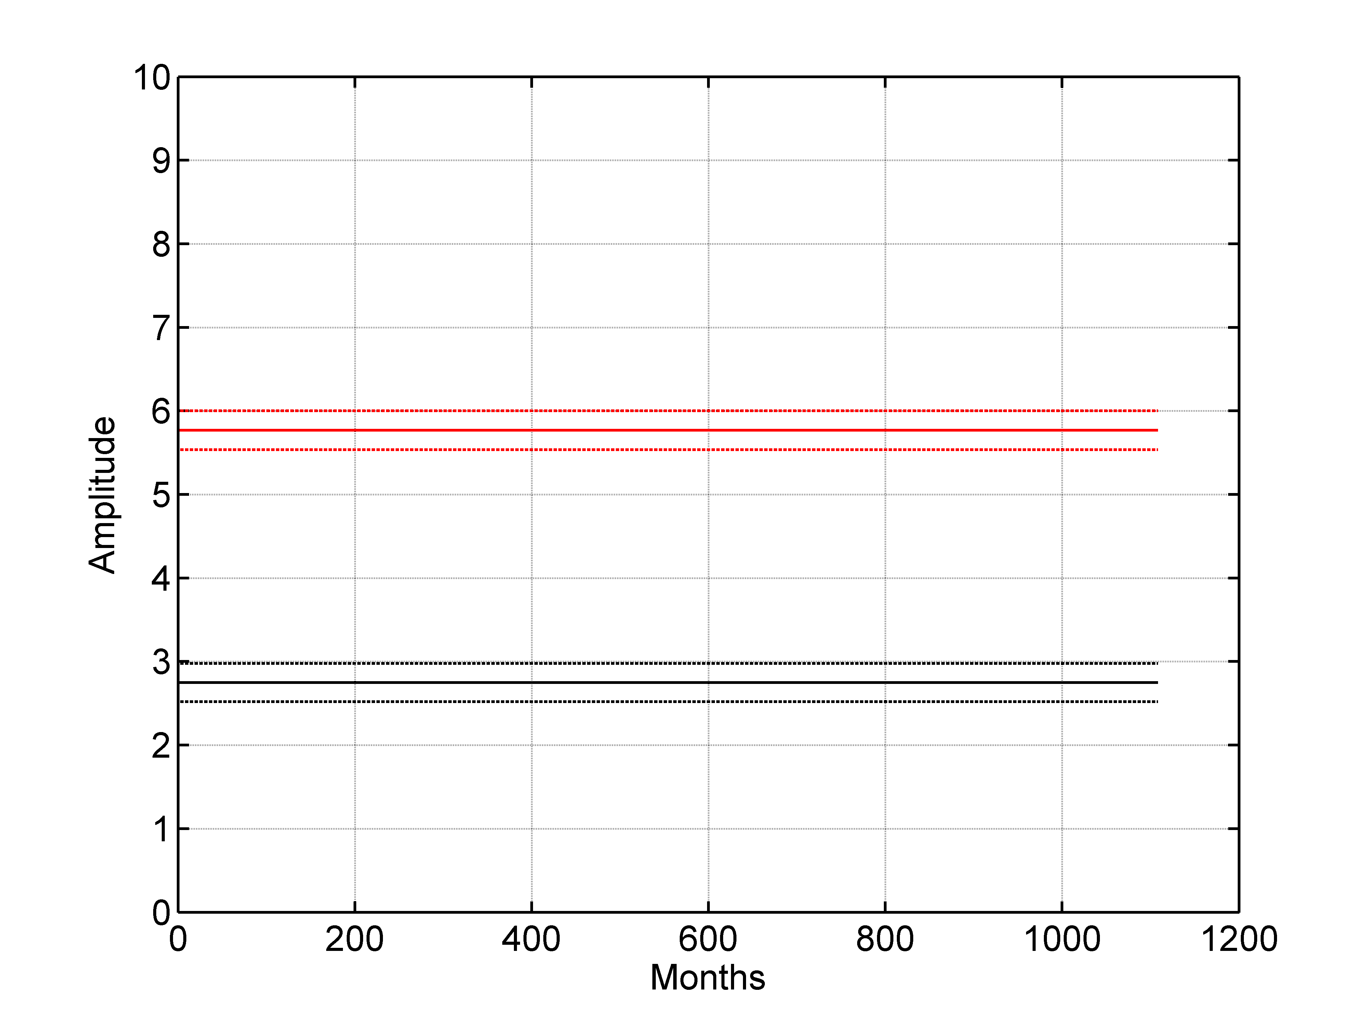
Figure 8. The amplitudes of 18.61 year cycle (red solid line) and 8.85 year cycle (black solid line). The dash lines are the 95% confidence intervals.

    - The fitting method used in S_TIDE
S_TIDE provides two fitting methods to solve the unknown parameters: ‘ols’ (Ordinary Least Squares) and 'robustfit' (Robust fit weighting method). Robustfit function can reduce the contribution of high-leverage data points, in order to improve the overall fit (but robustfit needs more computation time). The codes below compare the results obtained by two methods.

clear;load('N2_amp_astoria.mat')
[St1,Ht1,Gt1,coef,xout1,ju,Stint,Htint,Gtint]=s_tide(N2_amp,2,1,[1/(18.61*8760);1/(8.85*8760)],2,720,'spline','ols');
plot(xout1,'r','linewidth',1.2);
set(gca,'Fontsize',15,'linewidth',1.2);hold on;
[St2,Ht2,Gt2,coef,xout2,ju,Stint,Htint,Gtint]=s_tide(N2_amp,2,1,[1/(18.61*8760);1/(8.85*8760)],2,720,'spline','robustfit');
plot(xout2,'k','linewidth',1.2);
xlabel('Months');ylabel('Amplitude')

figure();plot(Gt1(2,:),'r','linewidth',1.2); hold on
plot(Gt2(2,:),'k','linewidth',1.2); hold on
set(gca,'Fontsize',15,'linewidth',1.2);grid on;
xlabel('Months');ylabel('Phase')

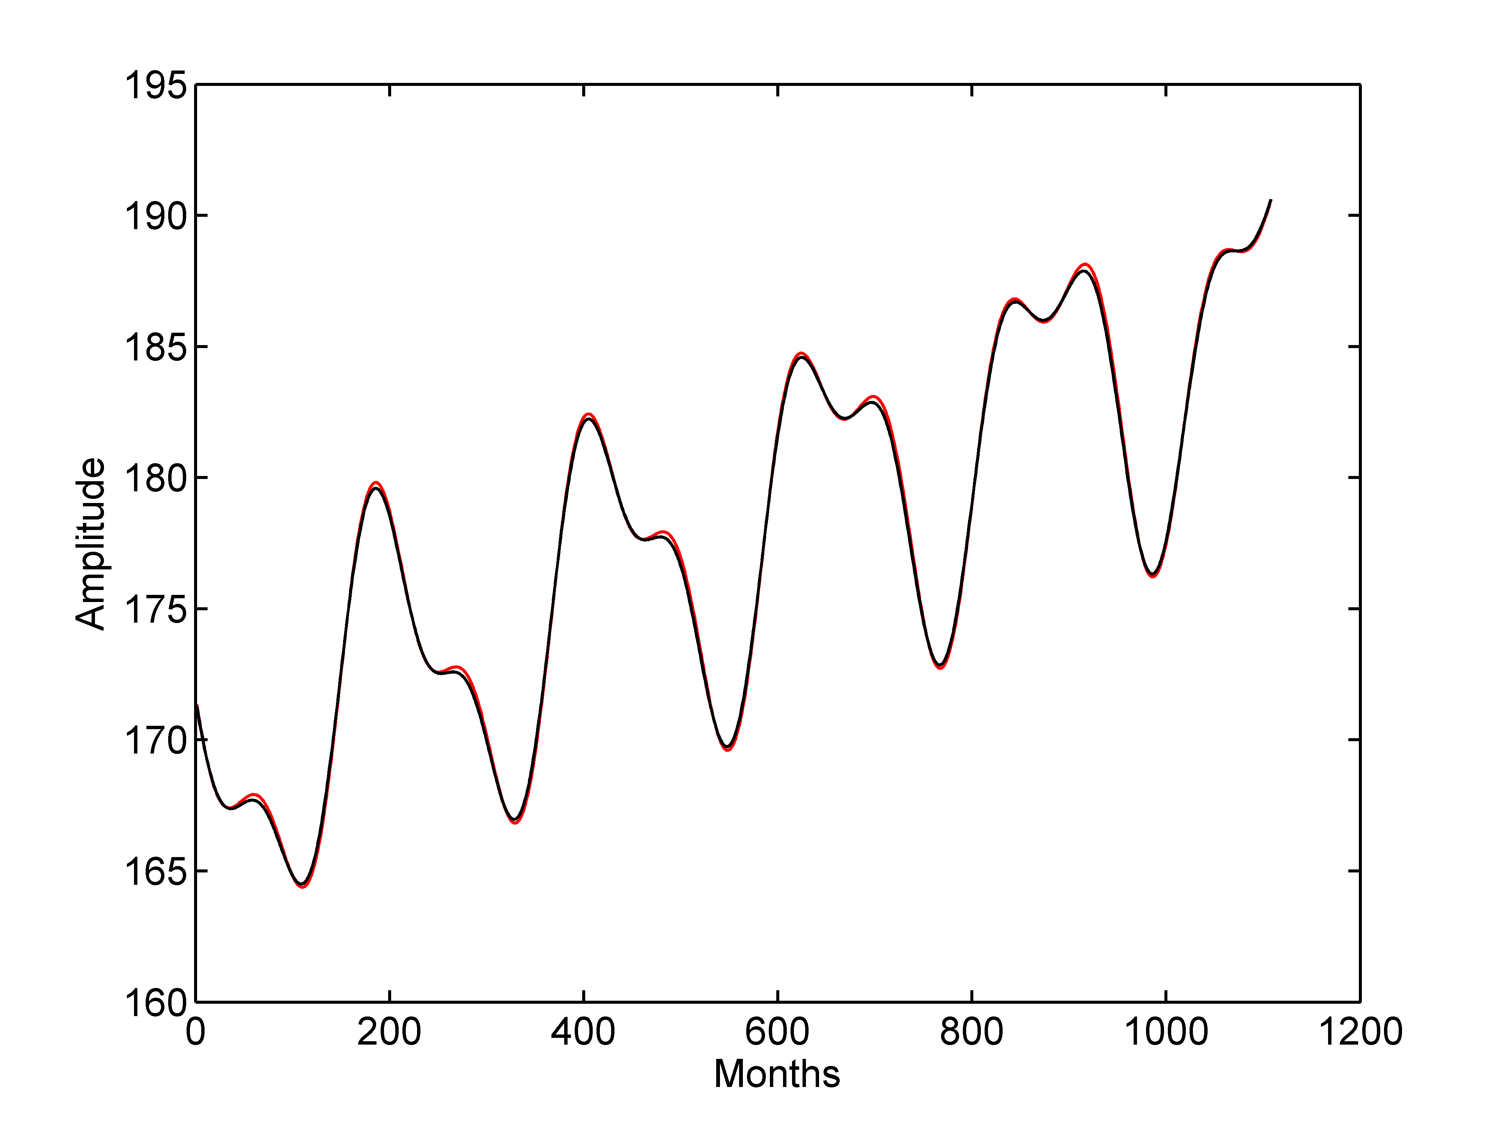
Figure 9. The fitting results obtained by ordinary least squares (red line) and robustfit (black line). In this case, the fitting results obtained by two methods are nearly same.
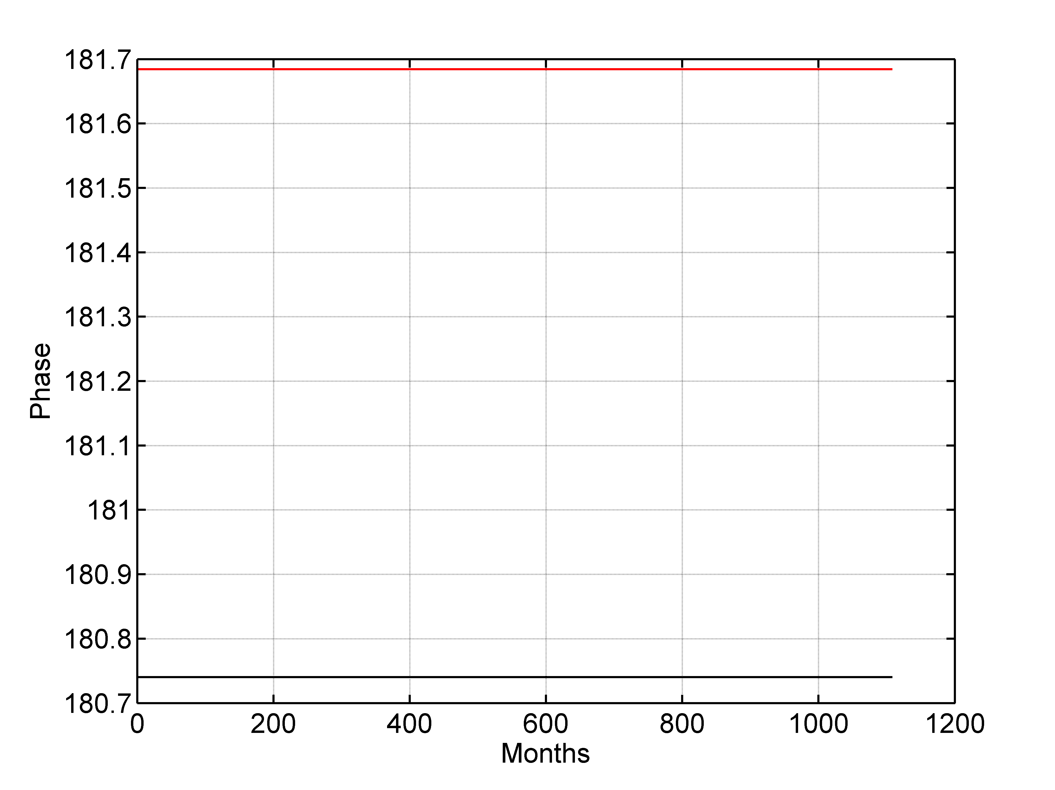
Figure 10. The red line and black line represent the phase of 8.85 year cycle using S_TIDE obtained by ordinary least squares and robustfit, respectively.

    - The interpolation method used in S_TIDE
S_TIDE provides three methods to connect IPs： linear interpolation、cubic spline interpolation as well as sinc interpolation. The cubic spline interpolation is recommended due to its stable, convergent and smooth characteristics. The codes below compare the results obtained by three interpolation methods.

x=[1 2 3 4 5];y=[0 1 0 -1 0];
xi=1:0.05:5;
IDP1=5;
nobs=length(xi);
S1 = s_calculate_coefficient(IDP1,nobs); %use spline interpolation
S2 = l_calculate_coefficient(IDP1,nobs); %use linear interpolation
S3 = sinc_calculate_coefficient(IDP1,nobs); %use sinc interpolation
yi_spline=S1*y';
yi_linear=S2*y';
yi_sinc=S3*y';
plot(x,y,'ro','MarkerSize',8.0);
hold on;plot(xi,yi_spline,'b','linewidth',1.1);
plot(xi,yi_linear,'m','linewidth',1.1);plot(xi,yi_sinc,'k','linewidth',1.1)
set(gca,'Fontsize',15,'linewidth',1.2);
legend('Given','Spline','Linear','Sinc')
ylim([-1.2 1.2])

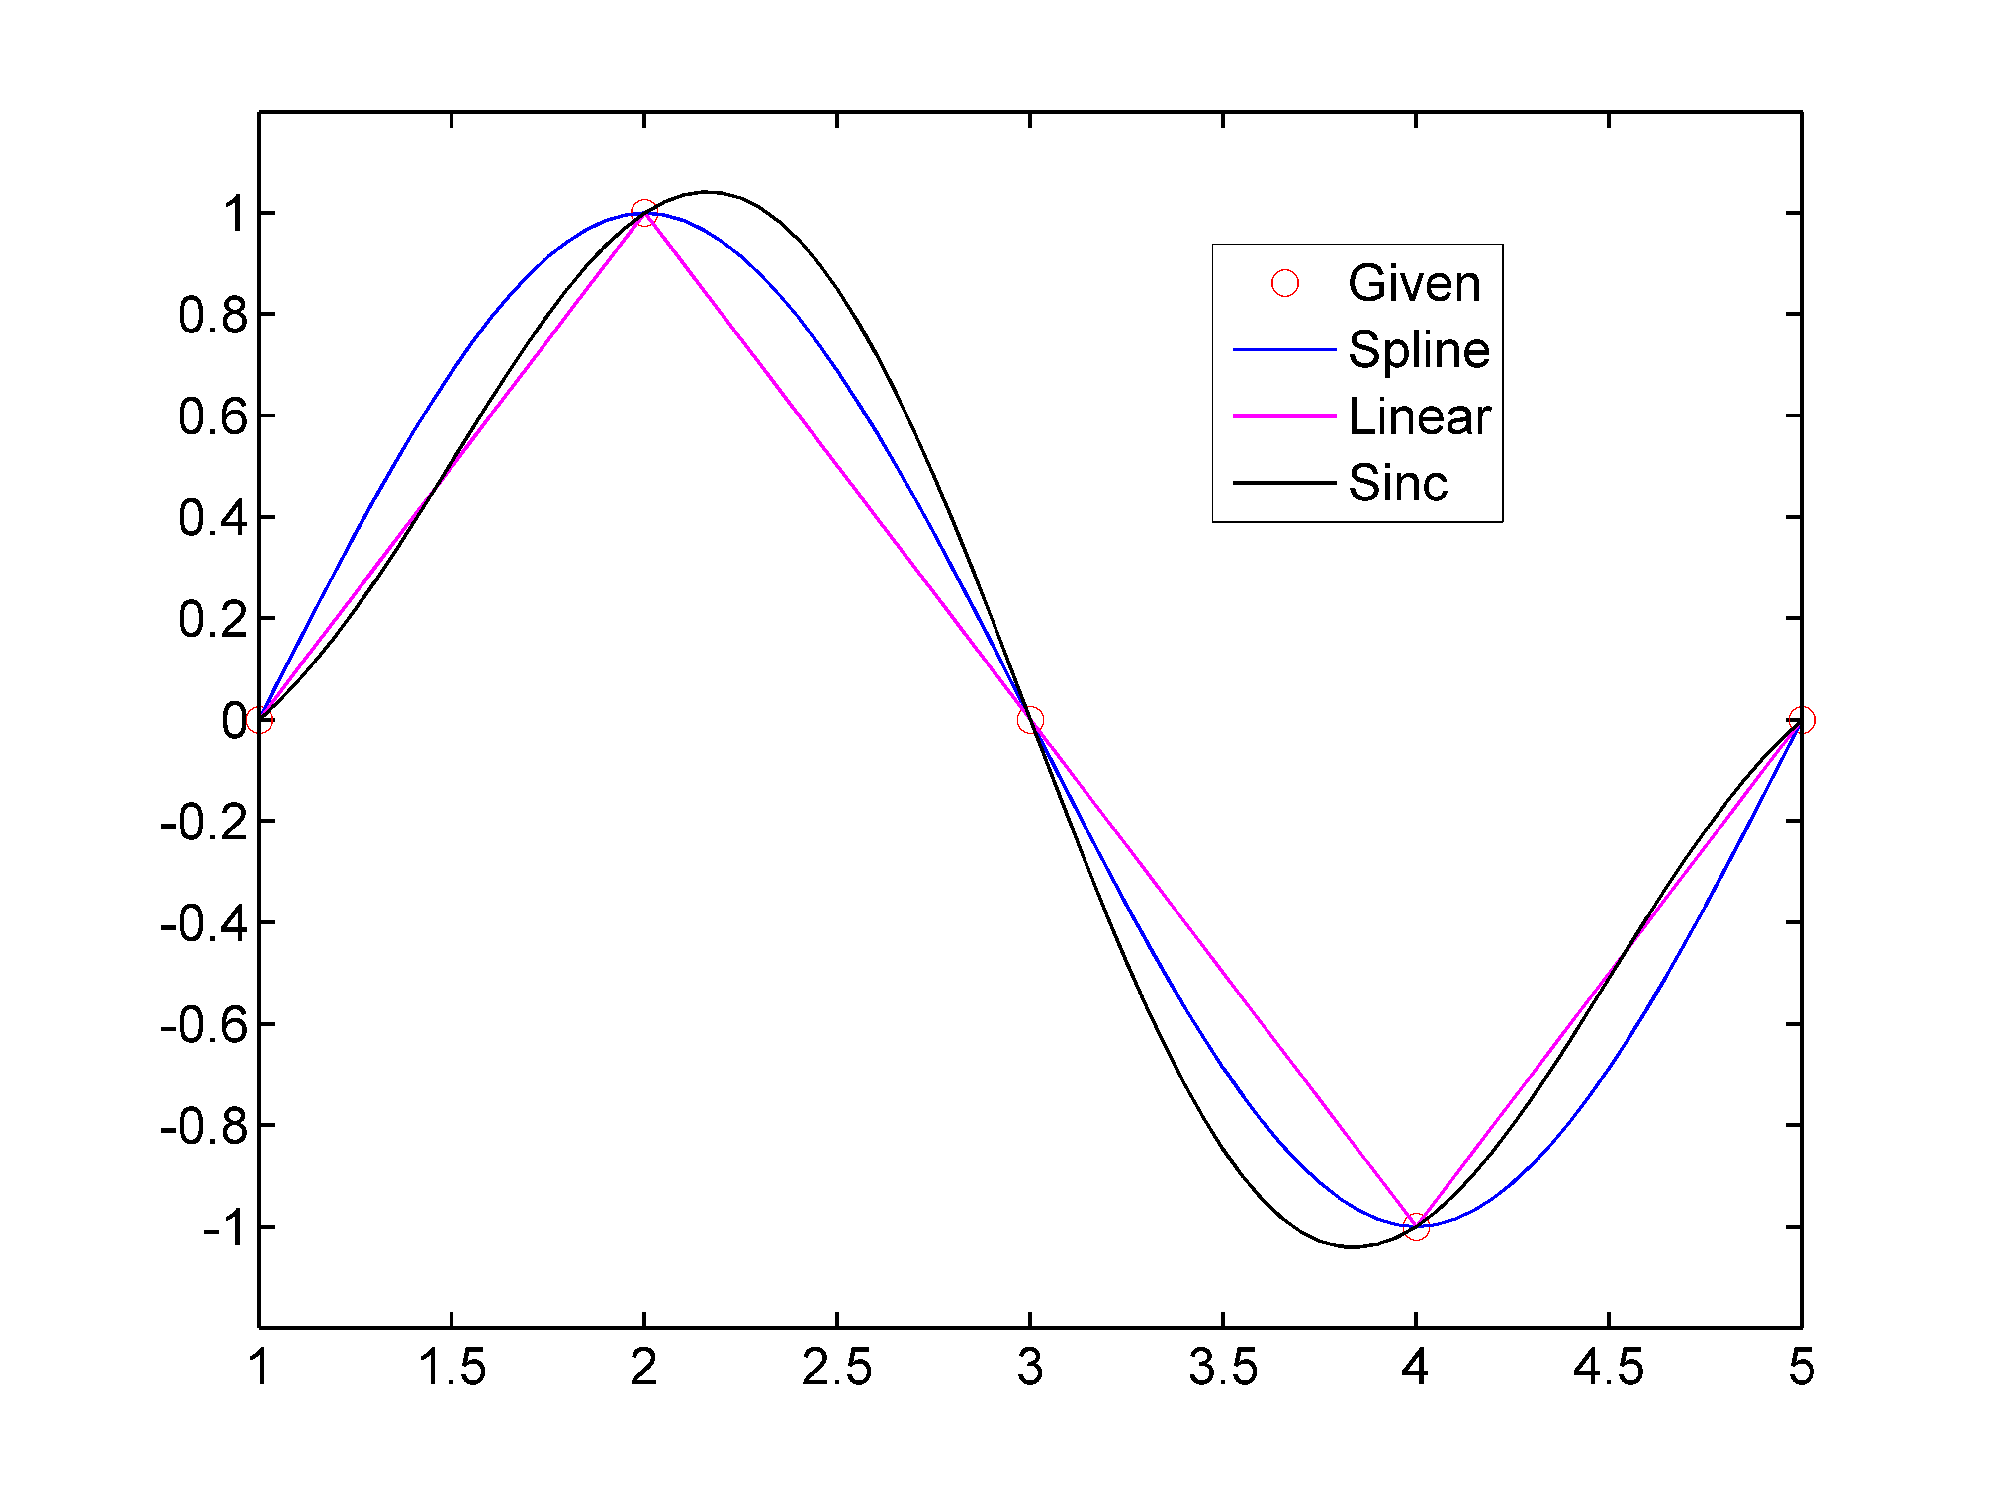
Figure 11. The results obtained by three interpolation methods.

    - Compared to T_TIDE
When IP number is set as 1, the amplitudes and phases calculated by S_TIDE are constant. In this case, the results obtained by S_TIDE are same to T_TIDE. The codes below compare the results obtained by S_TIDE (IP=1) and T_TIDE using hourly water levels at Kushiro.

figure();load kushiro.mat
[St,Ht,Gt,coef,xout,ju,Stint,Htint,Gtint]=s_tide(kushiro(1:8760),1,1,{'M2';'S2';'K1';'O1';'N2';'Q1';'P1';'K2'},8,1,'spline','ols');
plot(xout-St,'r','linewidth',1.1);hold on;
set(gca,'Fontsize',15,'linewidth',1.1);
[NAME,FREQ,TIDECON,XOUT]=t_tide(kushiro(1:8760),'interval',1, 'rayleigh',{'M2';'S2';'K1';'O1';'N2';'Q1';'P1';'K2'});
plot(XOUT,'k*');xlim([1 300])
xlabel('Time(hour)');ylabel('Water level(mm)')

Figure 12. The hindcast obtained by S_TIDE (red line) as well as T_TIDE (black asterisks)

If users do not input any tides，s_tide will automatically select tides according to the length of data and Rayleigh criteria (see the examples below).

[St,Ht,Gt,coef,xout,ju,Stint,Htint,Gtint]=s_tide(kushiro(1:8767),1,1,'autoselected','autoselected',1,'spline','ols');

Below are the outputs of S_TIDE, which are nearly the same as T_TIDE:

tidal amplitude and phase with 95% CI estimates
tide freq amp amp_err pha pha_err snr
SA 0.0001141 14.5843 20.802 -23.71 77.16 0.49
SSA 0.0002282 24.8904 20.828 152.41 46.20 1.4
MSM 0.0013098 15.0585 20.402 226.16 77.42 0.54
MM 0.0015122 25.2273 18.874 138.08 42.92 1.8
MSF 0.0028219 7.5535 18.409 221.90 140.95 0.17
MF 0.0030501 18.3465 19.661 14.29 61.96 0.87
ALP1 0.0343966 0.8332 2.600 -36.45 178.07 0.1
*2Q1 0.0357064 3.7988 2.633 152.00 39.17 2.1
*SIG1 0.0359087 6.1160 2.604 232.25 24.48 5.5
*Q1 0.0372185 33.7891 2.576 0.92 4.65 1.7e+02
*RHO1 0.0374209 6.9896 2.622 159.79 21.52 7.1
*O1 0.0387307 184.5366 2.612 -69.90 0.81 5e+03

    - Time-varying parameters obtained by S_TIDE
S_TIDE can obtain time-varying amplitudes and phases as well as mean water level (MWL). When IP number is set as 2, the results are linear (as shown in Figure 13).When using more IPs, the obtained variations are more complicated. As the IP number increases, the results obtained by S_TIDE show more high-frequency oscillations. The codes below show the MWL obtained by different IPs using S_TIDE (Figure 13).

figure();
[St,Ht,Gt,coef,xout,ju,Stint,Htint,Gtint]=s_tide(kushiro,1,5,{'M2';'S2';'K1';'O1';'N2';'Q1';'P1';'K2';'Ssa';'Sa'},10,1,'spline','ols');
plot(St,'b','linewidth',1.2);hold on
[St,Ht,Gt,coef,xout,ju,Stint,Htint,Gtint]=s_tide(kushiro,2,5,{'M2';'S2';'K1';'O1';'N2';'Q1';'P1';'K2';'Ssa';'Sa'},10,1,'spline','ols');
plot(St,'r','linewidth',1.2)
[St,Ht,Gt,coef,xout,ju,Stint,Htint,Gtint]=s_tide(kushiro,3,5,{'M2';'S2';'K1';'O1';'N2';'Q1';'P1';'K2';'Ssa';'Sa'},10,1,'spline','ols');
plot(St,'k','linewidth',1.2)
[St,Ht,Gt,coef,xout,ju,Stint,Htint,Gtint]=s_tide(kushiro,5,5,{'M2';'S2';'K1';'O1';'N2';'Q1';'P1';'K2';'Ssa';'Sa'},10,1,'spline','ols');
plot(St,'m','linewidth',1.2)
legend('IP=1','IP=2','IP=3','IP=5'); set(gca,'Fontsize',15,'linewidth',1.2);
xlabel('Time(hour)');ylabel('MWL(mm)');xlim([1 175200])

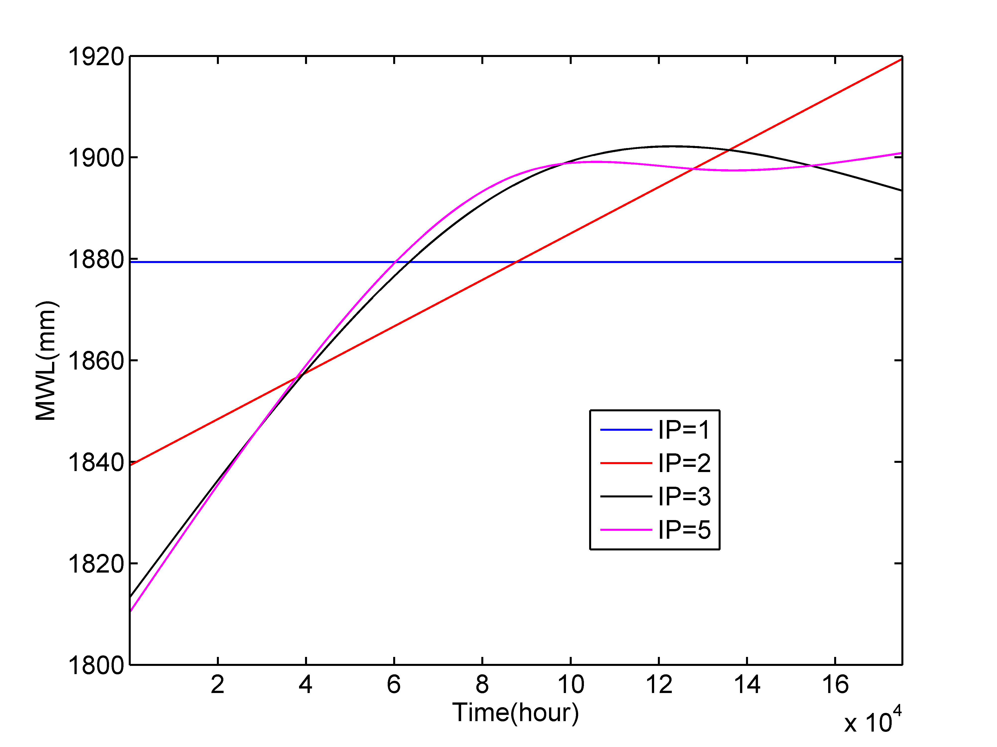
Figure 13. The Mean Water Level (MWL) obtained by different IP numbers using S_TIDE

The codes below calculate the variations of M2 and S2 tidal amplitudes at Kushiro using 21 IPs. It should be noted that the nodal cycle is not removed.

figure();
[St,Ht,Gt,coef,xout,ju,Stint,Htint,Gtint]=s_tide(kushiro,21,21,{'M2';'S2';'K1';'O1';'N2';'Q1';'P1';'K2';'Ssa';'Sa'},10,1,'spline','ols');
for i=1:2
subplot(2,1,i)
plot(Ht(i,:),'linewidth',1.1);hold on
plot(Ht(i,:)+Htint(i,:),'r','linewidth',1.1)
plot(Ht(i,:)-Htint(i,:),'r','linewidth',1.1)
set(gca,'Fontsize',15,'linewidth',1.2)
set(gca,'XTick',0:8760*2:8760*20)
set(gca,'XTickLabel',{'1993','1995','1997','1999','2001','2003','2005','2007','2009','2011','2013'})
ylabel('Amplitude/mm','Fontsize',15)
xlabel('Year','Fontsize',15)
grid on
xlim([0 8760*20])
if i==1
title('M2')
else
title('S2')
end
end

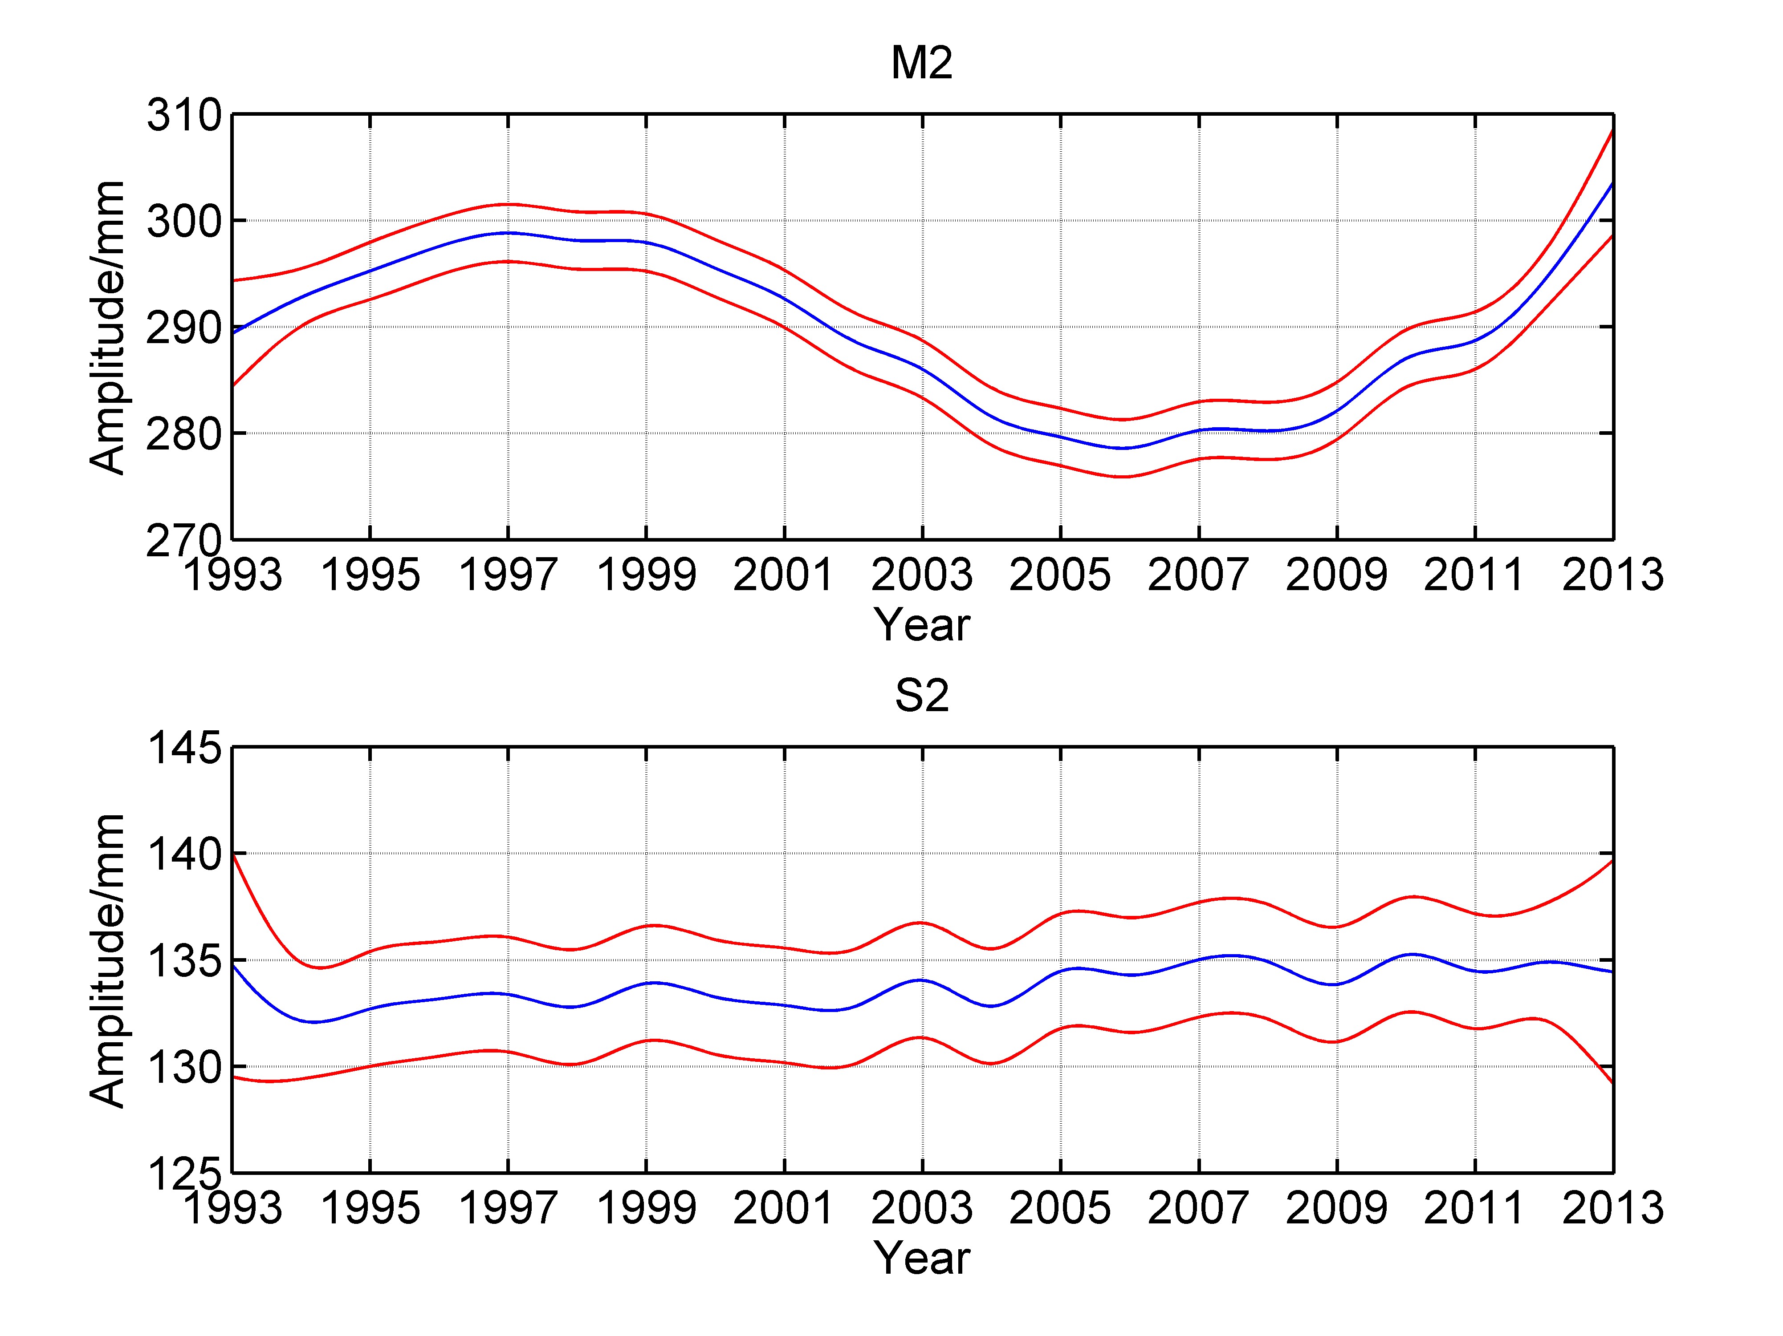
Figure 14. The blue lines mean the variations of M2 (up) and S2 (bottom) tidal amplitudes at Kushiro using 21 IPs. The red lines are the 95% confidence intervals.

    - Nodal correction using theoretical values
The codes below compare the inversed M2 tidal amplitudes and phases obtained by S_TIDE and T_TIDE at Kushiro (nodal corrected).

[NAME,FREQ,TIDECON,XOUT]=t_tide(kushiro(1:8760*3),'interval',1,'rayleigh',['M2';'S2';'K1';'O1';'N2';'Q1';'P1';'K2'],'latitude',42.5,'start time',[1993,01,01,00]);
[St,Ht,Gt,coef,xout,ju,Stint,Htint,Gtint]=s_tide(kushiro(1:8760*3),4,4,{'M2';'S2';'K1';'O1';'N2';'Q1';'P1';'K2'},8,1,'spline','ols');
[Hc,Gc,ff,uu,vv]=s_nodal_correction(Ht,Gt,[1993,01,01],8760*3,1,42.5,ju); figure()
subplot(2,1,1);plot(Hc(1,:),'r','linewidth',1.1);
hold on;
plot(TIDECON(6,1)*ones(1,8760*3),'k','linewidth',1.1);
ylabel('M2 Amplitude');title('nodal corrected')
set(gca,'Fontsize',15,'linewidth',1.2);xlim([0 8760*3])
subplot(2,1,2);plot(Gc(1,:),'r','linewidth',1.1);
hold on;
plot(TIDECON(6,3)*ones(1,8760*3),'k','linewidth',1.1);
ylabel('M2 Phase')
set(gca,'Fontsize',15,'linewidth',1.2);xlim([0 8760*3])
xlabel('Time(hour)')
legend('S\_TIDE','T\_TIDE')

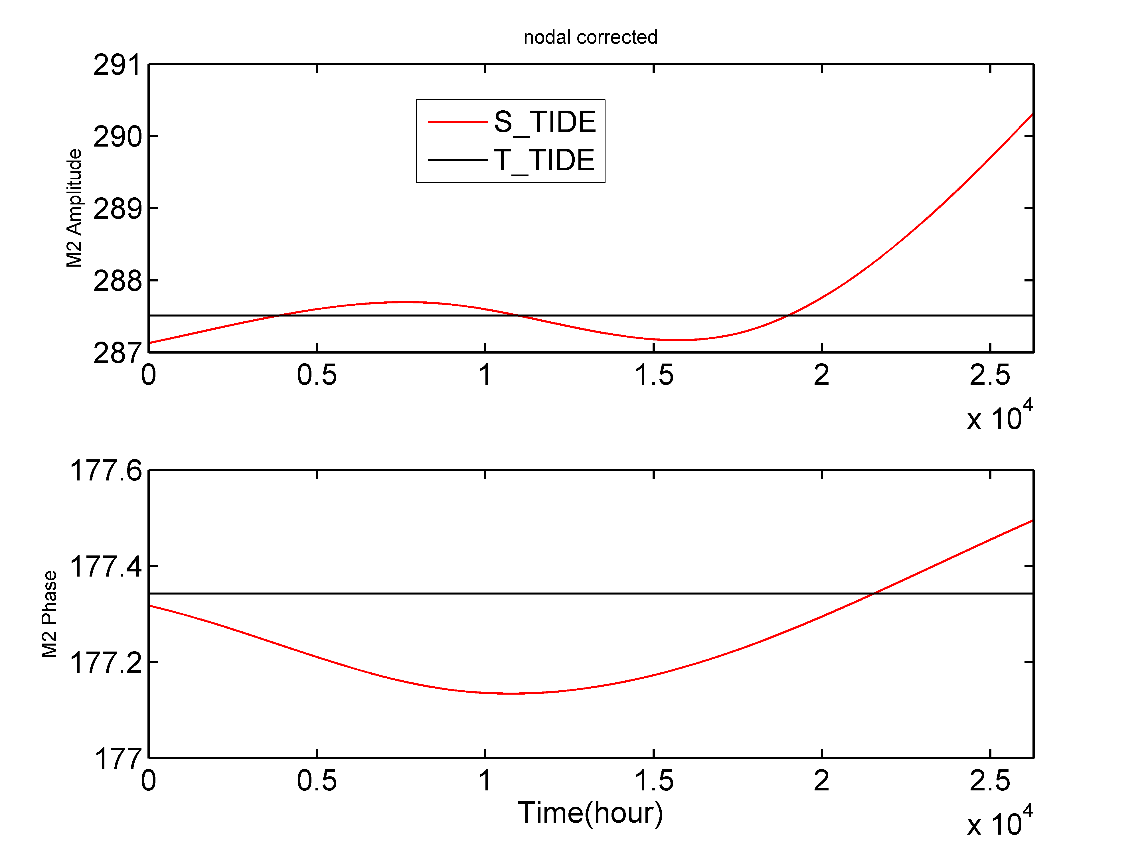
Figure 15. The M2 amplitudes and phases obtained by S_TIDE and T_TIDE (nodal corrected)

    - Wrong results induced by inappropriate input parameters
S_TIDE is not like a “point and shoot” camera. Caution should be exercised during selecting constituents and IPs. There is a trade-off between the number of constituents included in S_TIDE and the numbers of IP for constituents. We can use more IPs for fewer constituents, which means the changes of tidal properties can be more complex, and vice versa. Users need to determine suitable input parameters by trial and error. The codes below show the spurious results obtained by S_TIDE using inappropriate input parameters (Figure 16). When using 25 IPs for MWL, the obtained MWL includes some contributions from Sa constituent, thus, the Sa tide should be removed from the input parameters, otherwise, spurious variations will ensue.

figure();
[St,Ht,Gt,coef,xout,ju,Stint,Htint,Gtint]=s_tide(kushiro,25,21,{'M2';'S2';'K1';'O1';'N2';'Q1';'P1';'K2';'Ssa';'Sa'},10,1,'spline','ols');
subplot(2,1,1);plot(St,'r','linewidth',1.2)
set(gca,'Fontsize',15,'linewidth',1.2);
ylabel('MWL(mm)');xlim([1 175200])

[St,Ht,Gt,coef,xout,ju,Stint,Htint,Gtint]=s_tide(kushiro,25,21,{'M2';'S2';'K1';'O1';'N2';'Q1';'P1';'K2';'Ssa'},9,1,'spline','ols');
subplot(2,1,2);plot(St,'k','linewidth',1.2)
set(gca,'Fontsize',15,'linewidth',1.2);
xlabel('Time(hour)');ylabel('MWL(mm)');xlim([1 175200])

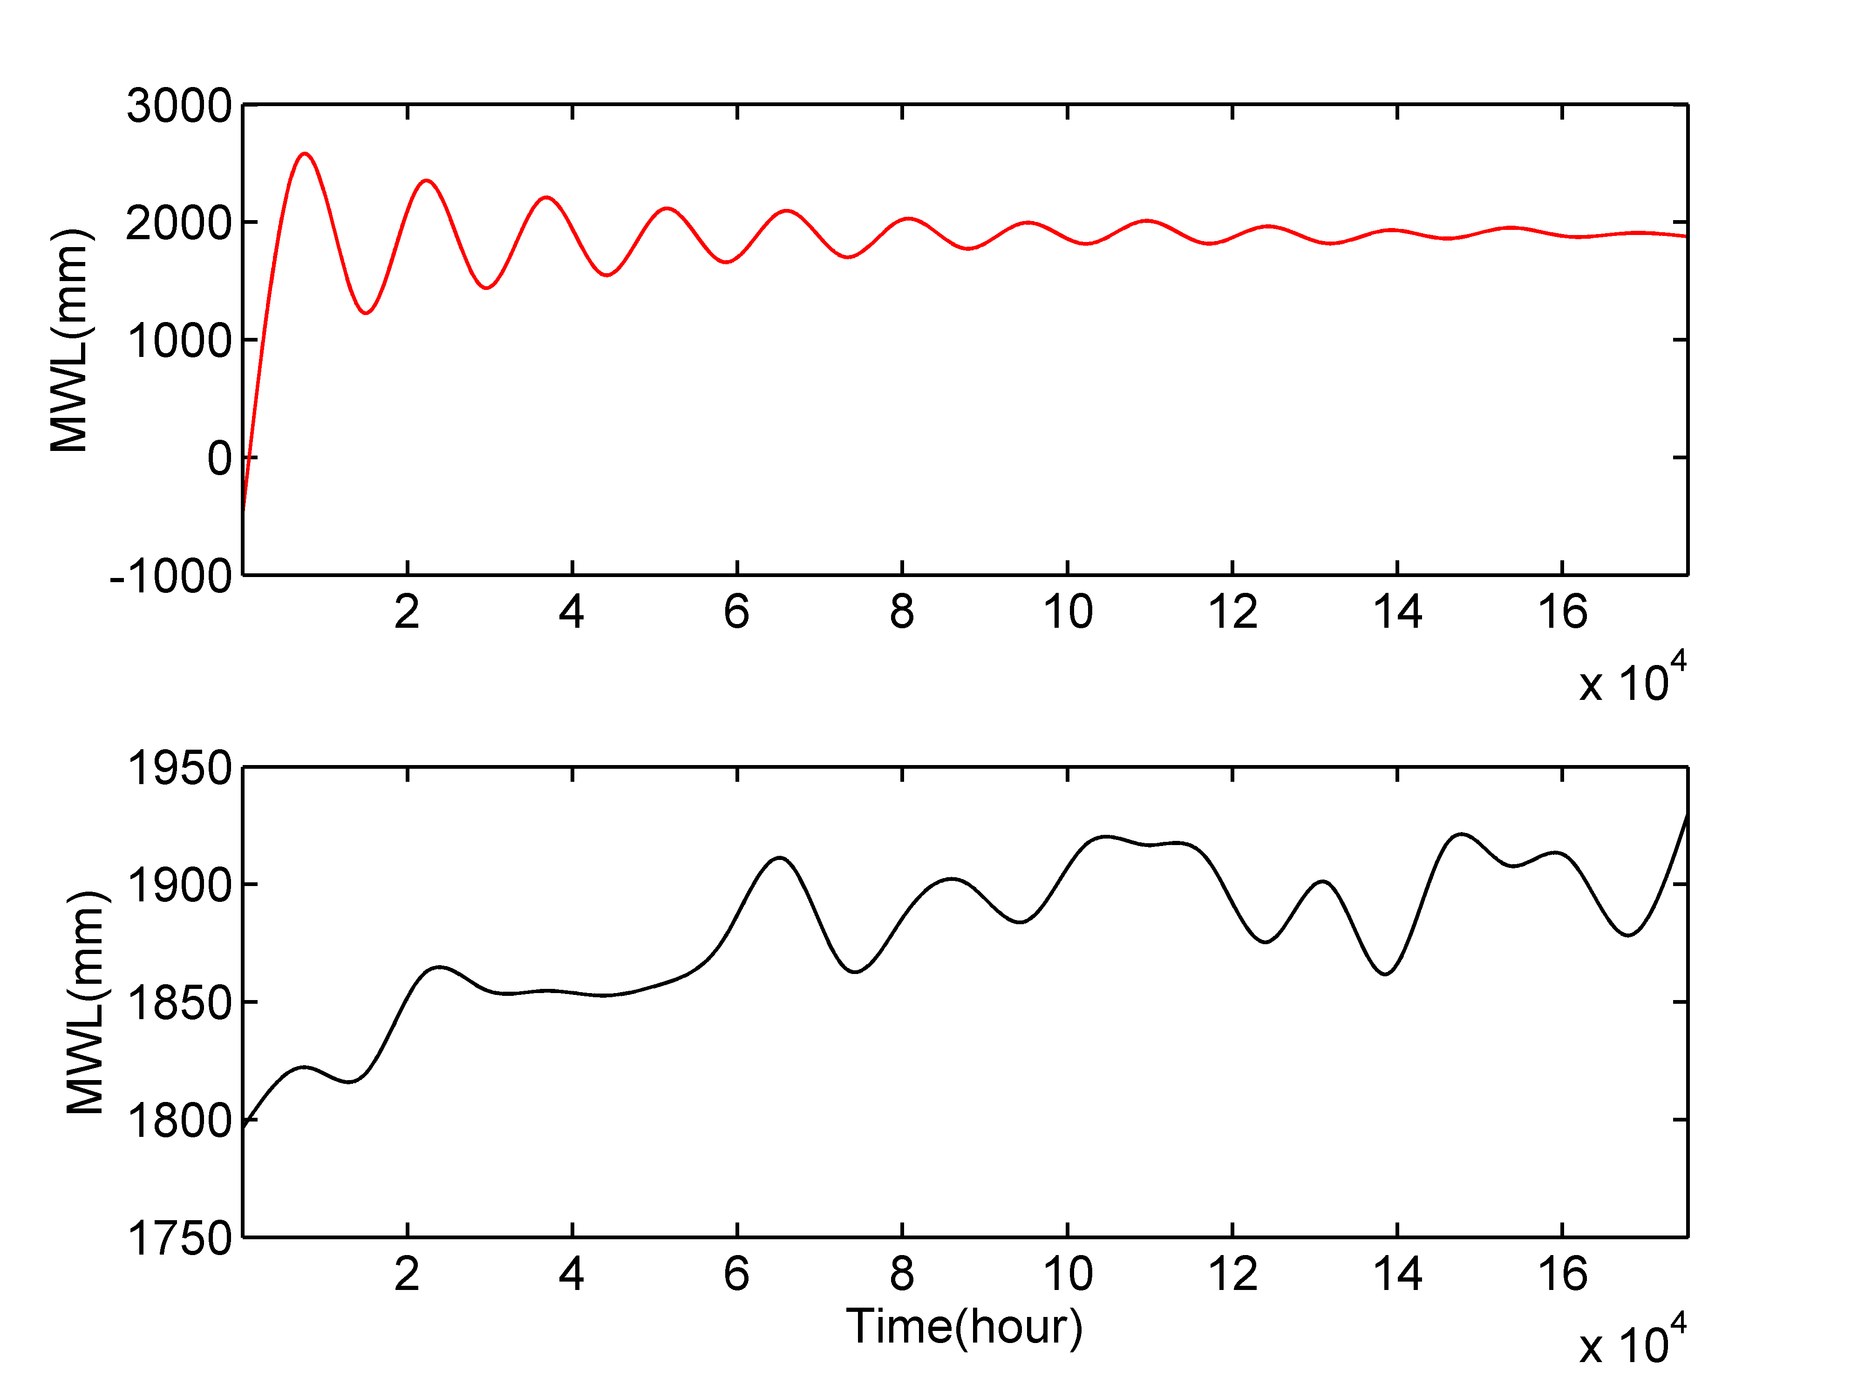
Figure 16. Spurious (red line) and correct (black line) MWLs obtained by S_TIDE

    - The potential applications of S_TIDE in other geophysical areas.
In geophysical area, there are many well-known cycles, such as the diurnal cycle and the annual cycle. Accurate extraction of these cycles is vital to geophysical studies. Traditionally a least squares approach is often used to extract these cycles and this approach assumes these cycles to be pure harmonics that do not vary with time, which may not reflect well the intrinsic non-stationarity and nonlinearity of the earth system. The non-stationarity and nonlinearity are universal in geophysical signals and S_TIDE can also be applied to these time series such as temperature and salinity. The codes below demonstrate how to extract annual cycle from daily river water temperature data. These codes can be directly copied into MATLAB, then, you can run these codes.
figure();load wt_SIO.mat
plot(wt,'b','linewidth',1.2);hold on
set(gca,'Fontsize',15,'linewidth',1.2);
xlabel('Time(day)');ylabel('Water Temperature');xlim([1 2200])
[St,Ht,Gt,coef,xout,ju,Stint,Htint,Gtint]=s_tide(wt,2,1,[1/(8760)],1,24,'spline','ols');
plot(xout,'r','linewidth',1.2)
[St,Ht,Gt,coef,xout,ju,Stint,Htint,Gtint]=s_tide(wt,2,10,[1/(8760)],1,24,'spline','ols');
plot(xout,'k','linewidth',1.2)
legend('Observation','Constant annual cycle','Changing annual cycle')

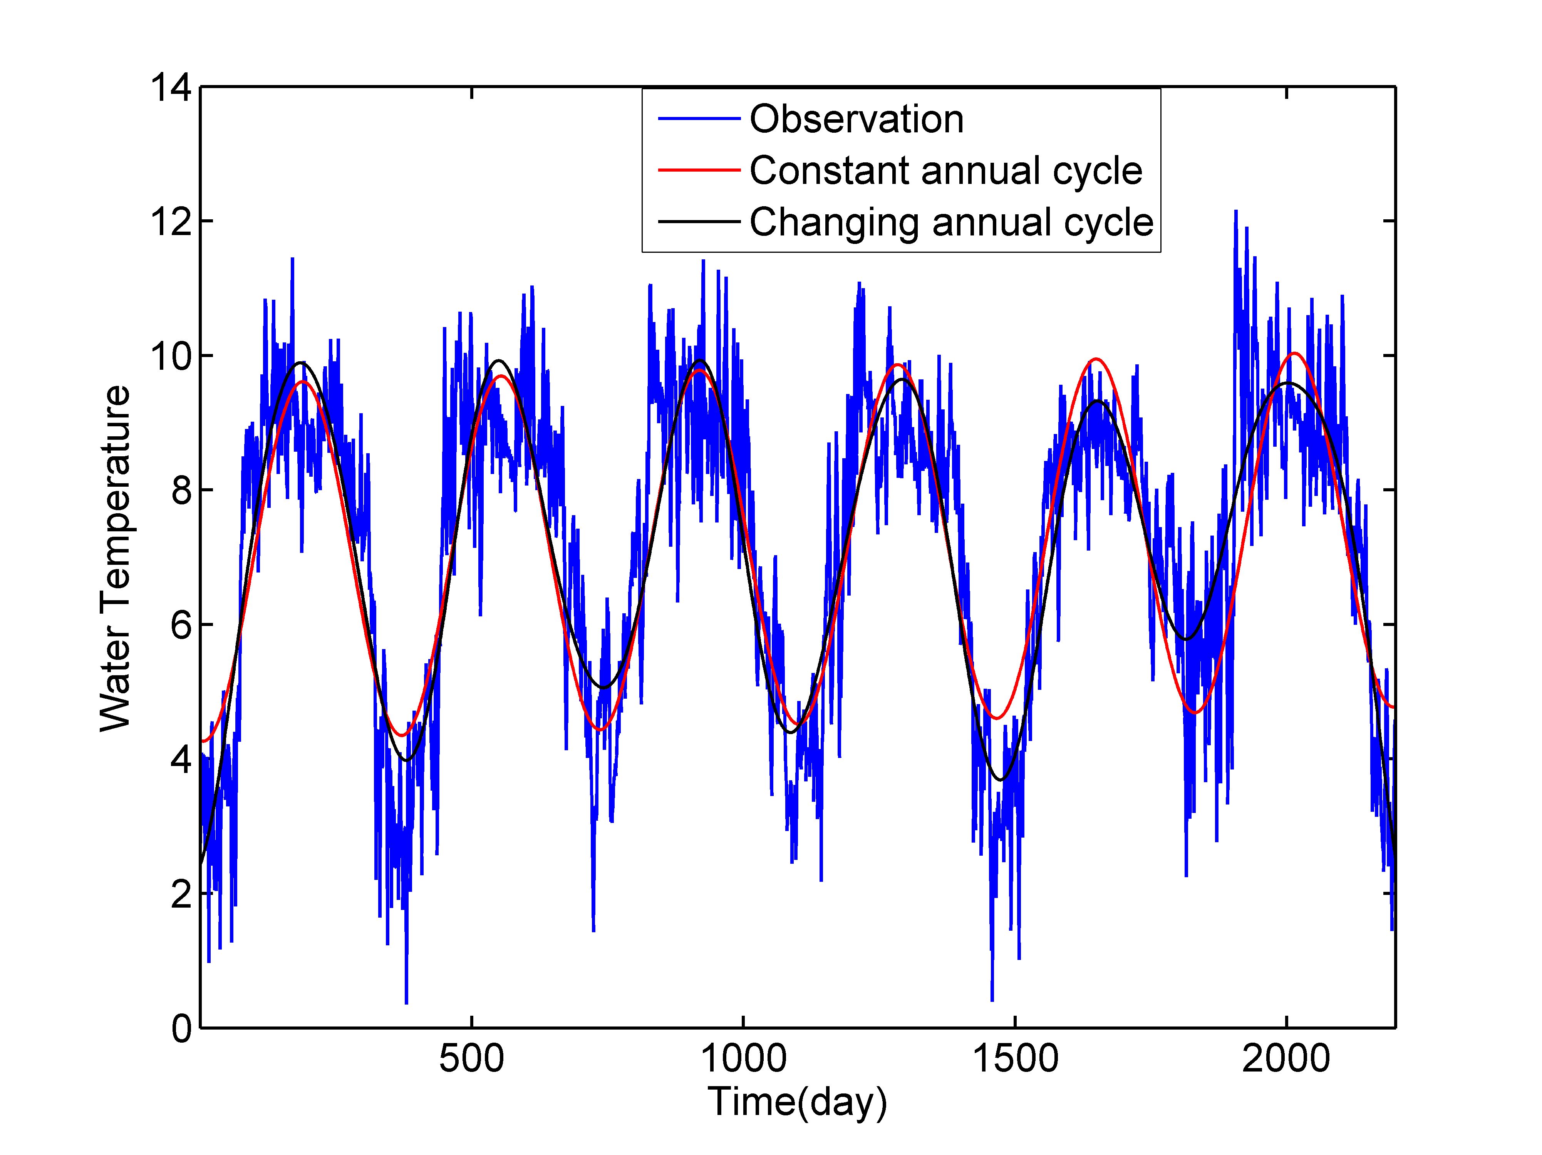
Figure 17. Observed daily river water temperature (blue line) at Sion station in the Rhone river. The red line and black line represent the stationary and modulated annual cycles extracted by S_TIDE, respectively.

    - The modification of main function s_tide.m
s_tide_m2.m is modified from the main function s_tide.m，it can give different constituents with different IP numbers. As shown in the codes below, for M2 and K1, 50 IPs are used. But for the rest tides, only 5 IPs are used.
load kushiro.mat
[St,Ht,Gt,coef,xout,ju,coefint]=s_tide_m2(kushiro,20,50,5,{'M2';'K1';'O1';'S2';'N2';'K2';'P1';'Q1'},8,2,1);
figure();plot(Ht(1,:),'k');hold on;plot(Ht(2,:),'r');plot(Ht(3,:),'b')
legend('M2','K1','O1');xlabel('Time(hour)');ylabel('Amplitude(mm)')

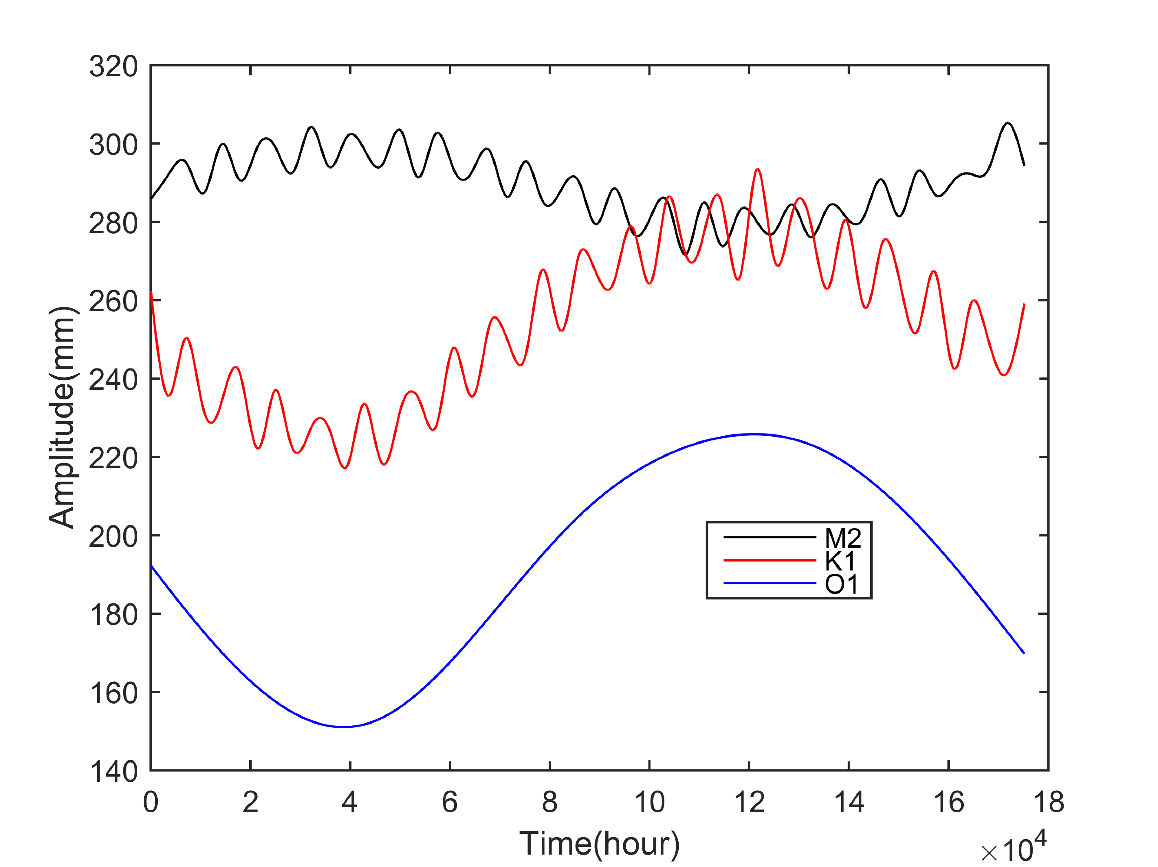
Figure 18. Time-varying tidal amplitudes obtained by s_tide_m2.m. The amplitudes of M2 and K1 contain high-frequency oscillations because more IPs are used.

    - The application of S_TIDE in satellite data
s_tide_m3.m is modified from s_tide.m. Because it considers time-varying nodal factors when calculating tidal amplitudes and phases, thus, it can be used to analyze satellite data.
load('satellite.mat');
cons={'M2';'S2';'K1';'O1';'N2';'Q1';'P1';'K2';'SA';'SSA'};lat=14.1633;
stime=[1992,10,31,19,43,37.71];
[St1,Ht1,Gt1,coef,xout1,ju,Stint1,Htint1,Gtint1,aa1,bb1,sigma_aa1,sigma_bb1]=s_tide_m3(satellite,2,1,cons,10,9.9156*24,'spline','ols',lat,stime);

plot(satellite,'*-','linewidth',1.1);hold on;
plot(xout1,'r','linewidth',1.1);
set(gca,'Fontsize',12,'linewidth',1.2)
xlim([1 101]);set(gca,'XTick',[1 51 101])
ylabel('Sea Level(m)');xlabel('Time')
set(gca,'XTickLabel',{'1992/10/31','1994/03/10','1995/07/19'})
legend('Observation','Hindcast')
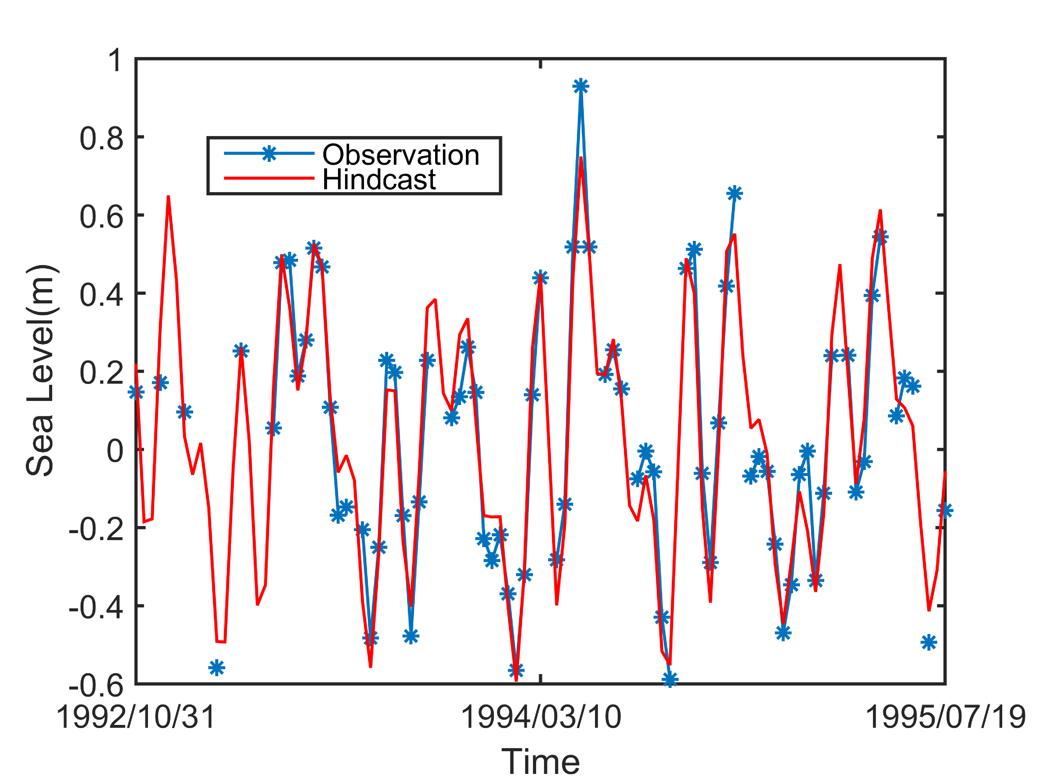
Figure 19. The hindcast of s_tide_m3.m and the satellite observations

